

**KAMPALA PRIVATE TEACHER’S EXAMINATIONS SERVICES**

***TEL: +25675120144/+256700666538/+256781928207***

**MID TERM I EXAMINATION 2024**

**P.4 INTEGRATED SCIENCE**

***Time Allowed: 2hours 15 Minutes***

**Pupil’s Name: …………………………………………..……………………**

**Class: …………………………………….………………………………………**

**School Name: ………………………………………………………………….**

**Read the following instructions carefully:**

|  |  |  |
| --- | --- | --- |
| **FOR EXAMINERS’**  **USE ONLY** | | |
| **Qn. No.** | **MARKS** | **EXR’S No.** |
| **1 - 10** |  |  |
| **11 – 20** |  |  |
| **21 – 30** |  |  |
| **31 – 40** |  |  |
| **41 – 43** |  |  |
| **44 – 46** |  |  |
| **47 – 49** |  |  |
| **50 - 52** |  |  |
| **53 - 55** |  |  |
| **TOTAL** |  |  |

1. This paper has two sections: **A** and **B**
2. Section **A** has 40 questions (**40 marks**)
3. Section **B** has 15 questions (**50 marks**)
4. Answer **all** questions. All the working for both sections A and B must be shown in the spaces provided.
5. All working must be done using a **blue** **or black** ball point pen or ink. Any work done in pencil will **NOT** be marked except drawings and diagram.
6. Unnecessary **changes** in your work and handwriting that cannot be easily read may lead to **loss of marks**.
7. Do not fill anything in the table indicated

**“For examiners’ use only”** and the boxes inside the question paper.

***Turn Over***

**SECTION A (40 marks)**

1. Name the part of an insect used for gaseous exchange.   
    ………………………………………………………………………………………………………………….
2. State any one use of roots to man.  
    …………………………………………………………………………………………………………………
3. Apart from killing germs and insect vectors, give any other reason why we iron   
    our clothes.   
    ……………………………………………………………………………………………………………….
4. What do we call the food made by plants?   
    ………………………………………………………………………………………………………………….
5. State the class of food got from eating fish.   
    …………………………………………………………………………………………………………………
6. Identify the use of a dustbin in a classroom.   
    ………………………………………………………………………………………………………………….
7. What is the difference between a vector and a germ?   
    ………………………………………………………………………………………………………………….  
    ………………………………………………………………………………………………………………….
8. Give any one danger caused by rats at home.   
    ………………………………………………………………………………………………………………….
9. Give a reason why loam soil is considered to be the best soil for growing crops?   
    ………………………………………………………………………………………..………………………

10. State any one immunisable disease in infants.   
 ………………………………………………………………………………………..……………………

11. Which sense is used to get communication from teachers in the class?   
 ………………………………………………………………………………………………………………….

1. Give any one example of man-made change. ………………………………………………………………………………………………………………….
2. Point out one agent of pollination.   
    ………………………………………………………………………………………………………………
3. Which component of air occupies the largest part of the atmosphere?   
    ………………………………………………………………………………………………………………
4. Identify the property of air illustrated below.

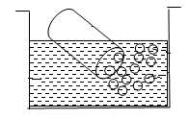………………………………………………………….

1. Which garden tool is used for cutting small trees and branches?   
    ………………………………………………………………………………………………………………
2. Give any one danger of wind to man.   
    ………………………………………………………………………………………………………………
3. Name the weather instrument used to measure the amount of rainfall received   
    in a place.   
    ………………………………………………………………………………………………………………
4. Give one difference between plants and animals.   
    ………………………………………………………………………………………………………………
5. What name is given to a young plant?   
    …………………………………………………………………………………………………………………
6. Write down any one group of living things.   
    …………………………………………………………………………………………………………………
7. Identify any one component of environment.   
    ………………………………………………………………………………………………………………
8. Why do living things eat?   
    …………………………………………………………………………………………………………………
9. Name the system of a flowering plant which grows above the ground.  
    ………………………………………………………………………………………………………………
10. Identify the type of family consisting of father, mother and their biological   
     children.   
     ………………………………………………………………………………………………………………
11. Which domestic bird is kept for security purpose at home?   
     ………………………………………………………………………………………………………………
12. Give any one example of non-flowering plant.   
     ………………………………………………………………………………………………………………
13. In which season do farmers plant their crops?   
     ………………………………………………………………………………………………………………
14. Suggest one way of controlling mosquitoes in our homes.   
     ………………………………………………………………………………………………………………
15. Give one basic need of people apart from food and clothing. …………………………………………………………………………………………………………………….
16. Mention one example of a plant that has a simple leaf. …………………………………………………………………………………………………………………….
17. Mention the component of air that helps a seed to germinate. …………………………………………………………………………………………………………………….
18. What do you understand by the term social insects?   
     ………………………………………………………………………………………………………………….
19. Mention the term given to the process by which plants make their own food.

………………………………………………………………………………………………………………….

1. State any one importance of leaves to plants.   
    ………………………………………………………………………………………………………………
2. Give any one characteristic of true insects.   
    ………………………………………………………………………………………………………………
3. Name the type of compound leaf drawn below.   
   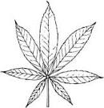

………………………………………………………………….

1. To which type of plants does a maize plant belong?   
    ………………………………………………………………………………………………………………
2. Identify one way in which plants with weak stems climb others.   
    ………………………………………………………………………………………………………………
3. Apart from protection, give one other reason why a chameleon changes its   
    colour?

………………………………………………………………………………….………………………………

**SECTION B (60 Marks)**

1. Match the following animals with their movement

Baby Jumps

Snake Glides

Frog Flies

A bird Crawls

**Animal Movement**

1. Baby ……………………………………………………………………………………………….
2. Snake ……………………………………………………………………………………………..
3. Frog ……………….……………………………………………………………………………
4. A bird ……………………………………………………………………………………………
5. a) State any two examples of common accidents at school.
6. …………………………………………………….……………………………………………………
7. ………………………………………………………………………………………………………….

b) What do we call the person who gives first aid? ……………………………………………………………………………………………………………………..

c) Give any one item found in a first aid box. ……………………………………………………………………………………………………………………..

1. a) What is weather …………………………………………………………………………………………………………………….

b) State any two conditions of weather.

i) ………………………………………………………………………………………………………

ii) …………………………………………………………………………………………………….

c) Which element of weather helps farmers to harvest most crops?   
 ………………………………………………………………………………………………………………

1. a) In the space below, draw the following types of roots.

|  |  |
| --- | --- |
|  |  |
| **Tap root system** | **Fibrous root system** |

b) Give two uses of roots to plants.

i) ………………………………………………………………………………………………………

ii) ………………………………………………………………………………………………………

1. a) Which stage of a housefly does not feed? ……………………………………………………………………………………………………………….

b) How many stages of development do the following insects under go.

1. A mosquito …………………………………………………………………………………
2. A grass hopper ………………………………………………………………………………..
3. A Cockroach ………………………………………………………………………………….
4. a) What is germination?   
    …………………………………………………………………………………………………………

…………………………………………………………………………………………………………

b) Write down two conditions necessary for germination to take place.

i) ………………………………………………………………………………………………………

ii) ……………………………………………………………………………………………………..

c) Name the type of germination drawn below.

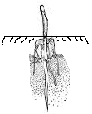

…………………………………………………………………………………………………………………..

1. Below is a water cycle, use it to answer the questions.

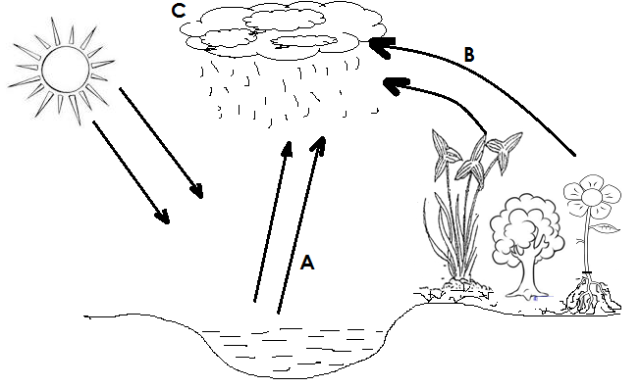

1. Identify the processes taking place at;

i) A …………..………………………………………………………………………………………..

ii) C …………………………………………………………………………………………………….

1. Give any two uses of water to people at school. i)………………………………………………………………………………………………………..

ii) ………………………………………………………………………………………………………

1. a) Define the term dehydration.   
    …………………………………………………………………………………………………………
2. State one cause of dehydration. ………………………………………………………………………………………………………….
3. Identify any two signs shown by a dehydrated person.

i) ……………………………………………………………………………………………………

ii) ……………………………………………………………………………………………………

1. a) State one way in which soil is formed.   
    ………………………………………………………………………………………………………………

……………………………………………………………………………………………………………….

b) Write any two components of soil.

i) ……………………………………………………………………………………………………

ii) ……………………………………………………………………………………………………..

c) How is soil useful to people in your community? ……………………………………………………………………………………………………………………..

……………………………………………………………………………………………………………………..

Below is a diagram of a bean seed. Use it to answer questions that follow.

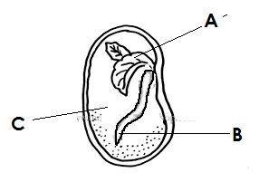

1. Name the parts marked

A ……………………………………………………..

B ……………………………………………………….

C ………………………………………………………

b) Which part of the bean seed develops into a shoot system?   
……………………………………………………………………………………………………………………..

51. How do these animals protect themselves?

1. Bees ……………….……………………………………………………………………………
2. Dogs ………………………………………………………………………………………………
3. Snakes ………………………………………………………………………………………….
4. Chameleon …………………………………………………………………………………….
5. a) What is personal hygiene? ………………………………………………………………………………………………………………….

…………………………………………………………………………………………………………………

b) Give any two activities a P4 child can do to promote personal hygiene.

i) ……………………………………………………………………………………………………………..

ii) ……………………………………………………………………………………………………………..

c) Write any one item one can use to keep him/her self clean. ……………………………………………………………………………………………………………………..

1. a) What is leaf venation?   
   ……………………………………………………………………………………………………………………

……………………………………………………………………………………………………………………

1. Identify the two types of leaf venation.
2. …………………………………………………………………………………………………………….
3. …………………………………………………………………………………………………………….
4. Give the use of veins in a leaf of a plant. ……………………………………………………………………………………………………………………………………………………………………………………………………………………………….
5. The diagram below is of a flowering plant. Use it to answer questions.

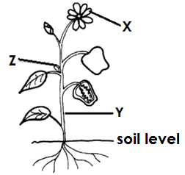

1. Name the parts marked;

X ………………………………………………

Y ……………………………………………

Z ………………………………………...

1. Write one structure that develops from the axillary bud. ………………………………………………………………………………………………………………
2. a) Give any one way food can get contaminated.   
    ……………………………………………………………………………………………………………..

b) State any three ways of preserving food.

1. ……………………………………………………………………………………………………………..
2. ……………………………………………………………………………………………………………….
3. ………………………………………………………………………………………………………………
4. a) What is First Aid?

……………………………………………………………………………………………………………………

b) Mention any two places which should have a First Aid box.

i) ………………………………………………………………………………………………………………..

ii) ………………………………………………………………………………………………………………

c) Suggest one danger caused by accidents.

…………………………………………………………………………………………………………………..

***“GOOD LUCK”***